Dramatic Trailer;

Compilation of art assets/music/dialogue as yet to be decided.

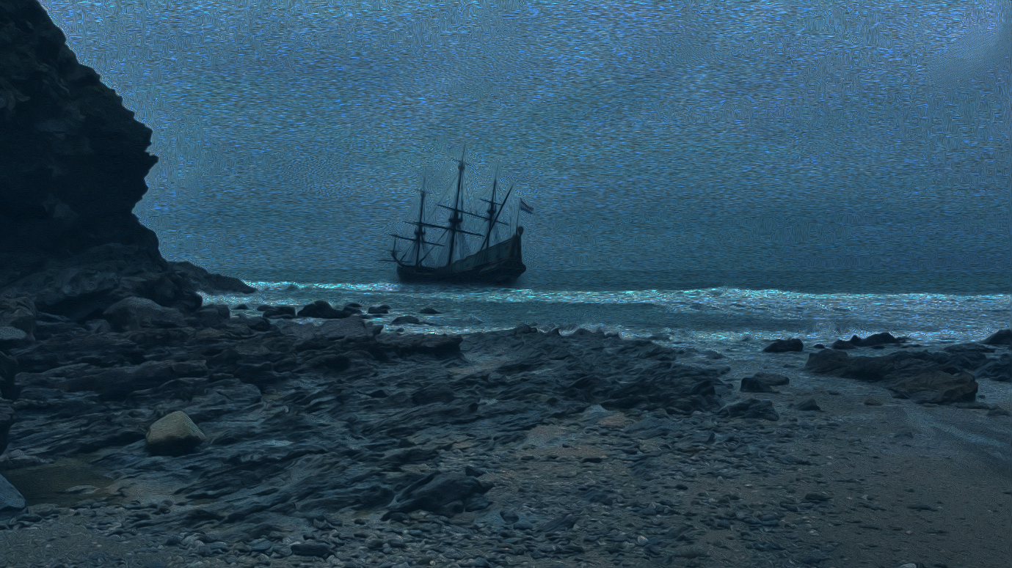

Draft Script / Storyboard;

Hi guys! I’m excited to be introducing the latest creation from the brilliant minds at GoupFourteen called “Open Your Eyes”. If you haven’t heard of this release yet, then hold onto your seats because the water is about to get rough.



“Open Your Eyes” is a dark adventure based on the real-world events of the rather unknown tale of an early-17th century ship called the Batavia. It features all the usual seafaring fun such as mutiny, betrayal and murder, but not how you would think.



Perhaps surprisingly, this game has attracted some attention due to its moral choice aspects. Now, I can imagine you all rolling your eyes saying, “*not another moral choice system*”, but believe me when I say, this will really re-define the genre.

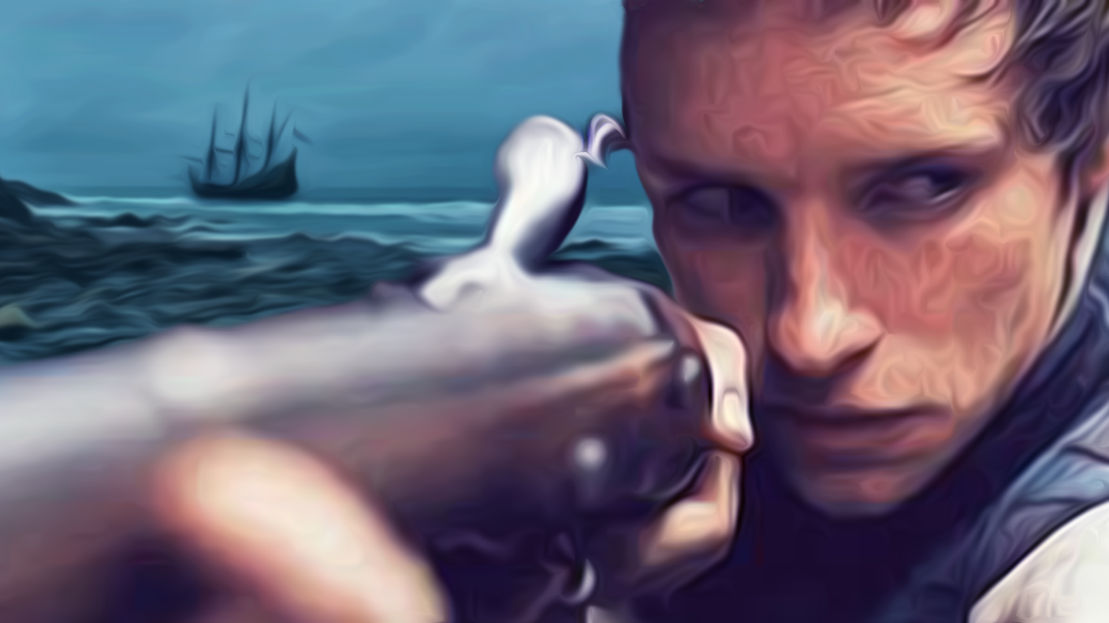

The story begins aboard the ship already mentioned, the “Batavia”. You play as Gerrit Janszoon, a cabin boy and lowest member of the crew, who has only one goal: to survive. Never will you feel so overwhelmed and underpowered in a game and, likewise, invested in the success of a character.

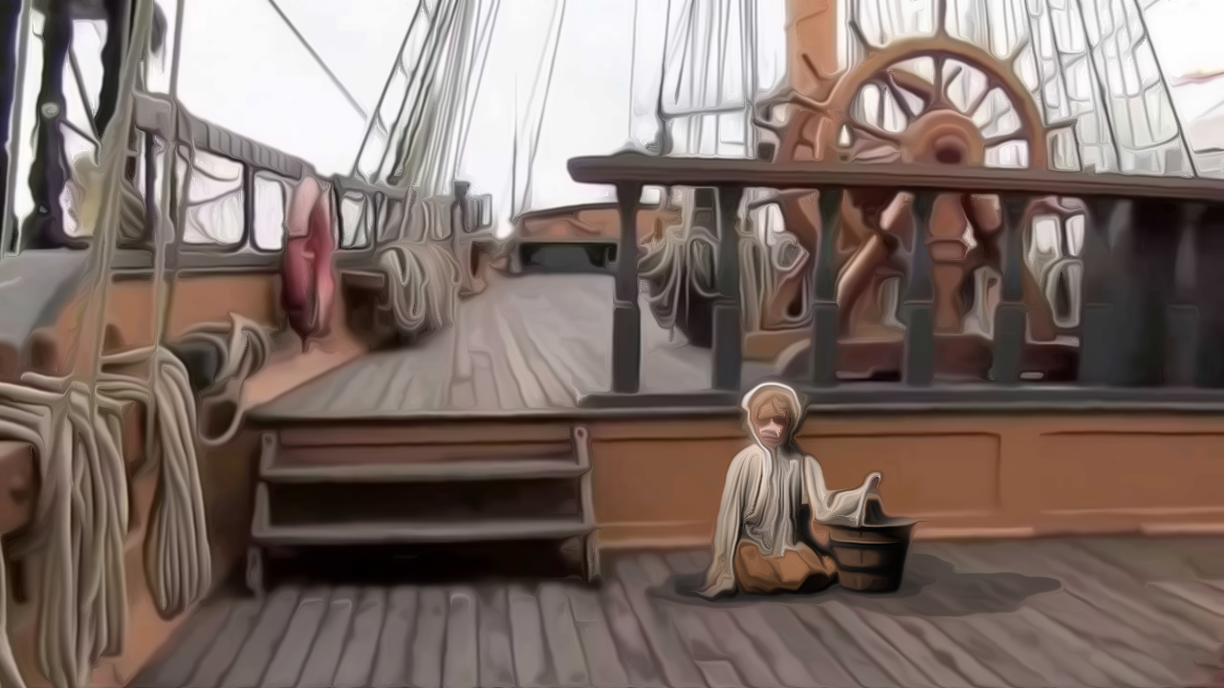

Right from the start decisions must be made and faction alliances start to form without any obvious feedback to the player. Diplomacy and intrigue are the name of the game: alliances are made and broken as the stress of the journey increases, and loyalties are tested when mutiny is in the air. Most moral choice systems offer one of two polarised choices, of which the player can usually see the obvious long-term outcome, but playing this game might see you questioning your own morals.



One of the key scenarios in the early phase of the game sees you attempting to investigate a suspected uprising under captain’s orders, and while doing so, you get caught up in a group assault on one of the female civilians on the ship. Do you go along with it, hoping you might not be found guilty later? Or do you refuse, and risk being silenced by the mutineers? Be aware that the weight of your choices might not affect you until much later in the game, far beyond the point of reloading a save. Better make a swift decision because the NPCs see your delayed response as untrustworthy and might get startled and act out.

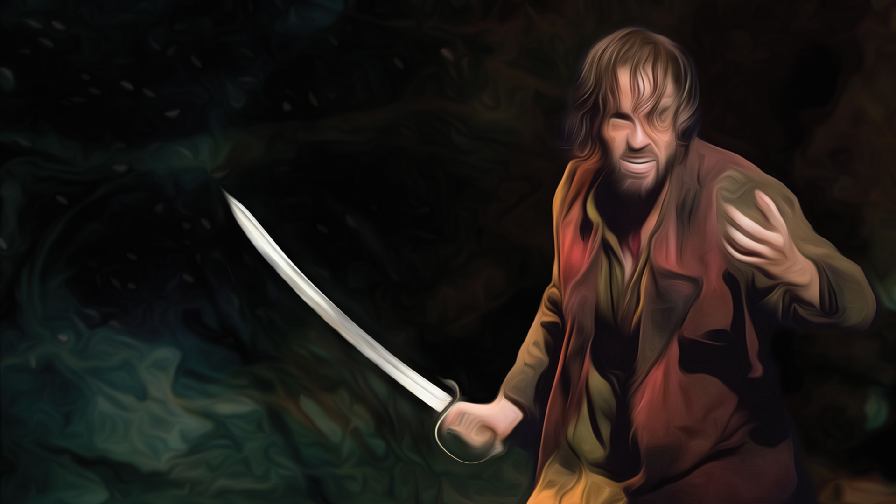

Further to this, attempting to recant on a decision you make can very suddenly end in death, which is another key facet of the mechanics. The game conditions players to fear the weight of every decision they make no matter how seemingly insignificant.

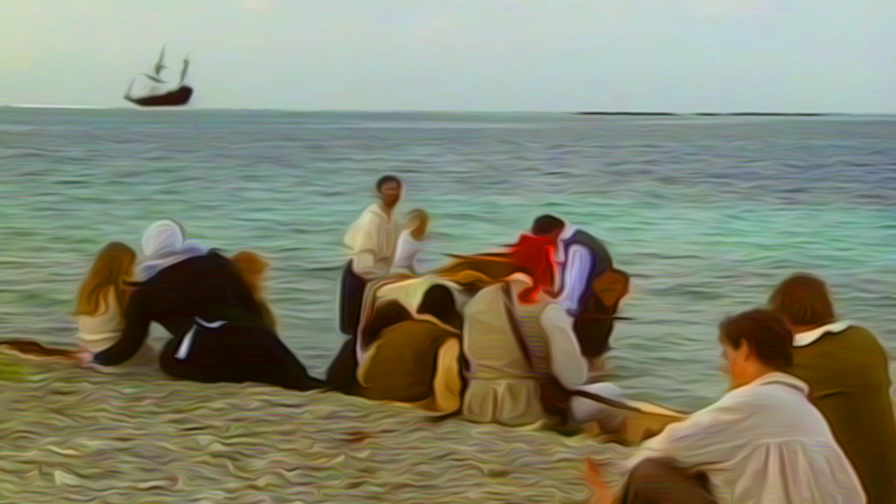

In “Open Your Eyes” the NPCs are three dimensional, remembering not only your previous interactions with them, but also altering their attitude to you based on your relationship with their network of friends. And things only get worse at the end of Act 1 where you are shipwrecked on a remote island with very little food and water, surrounded by friends and strangers, mutineers and civilians, and all your actions up to that point come back to haunt you. Sounds enticing, right?



That said, don’t feel so powerless. While in Gerrit’s shoes, you have the chance to influence one of many game endings, such as defeating the mutinous rebels with the soldiers and escaping on the rescue boat; joining the mutiny and defeating the soldiers; avoiding both factions and somehow still surviving as a stowaway on the rescue boat; or commandeering the rescue boat to begin your career as a pirate. Which will you choose?

